UNVEILING MARKET INSIGHTS
PROJECT REPORT
- INTRODUCTION :
- OVERVIEW :

Unveiling market insights is a critical aspect of understanding and succeeding in the business world. It involves the process of gathering, analyzing, and interpreting data to gain a deeper understanding of market dynamics, trends, and consumer behavior. Market insights are essential for making informed business decisions, identifying opportunities, and mitigating risks.

PURPOSE:
- The purpose of unveiling market insights is to gain a deep understanding of a particular market or industry. This process involves gathering and analyzing data and information to provide valuable, actionable knowledge about market trends, consumer behavior, competitive landscape, and other factors that can influence business decisions. Here are some specific purposes and benefits of unveiling market insights

- PROBLEM DEFINITION & DESIGN THINKING:

Here we see the Empathy map and Brainstorming map about

UNVEILING MARKET INSIGHTS

EMPATHY MAP

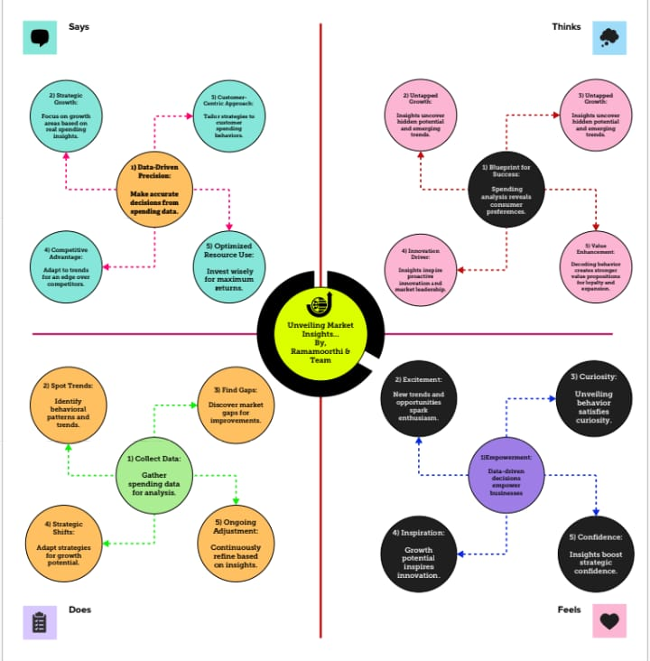

- BRAINSTORMING MAP:
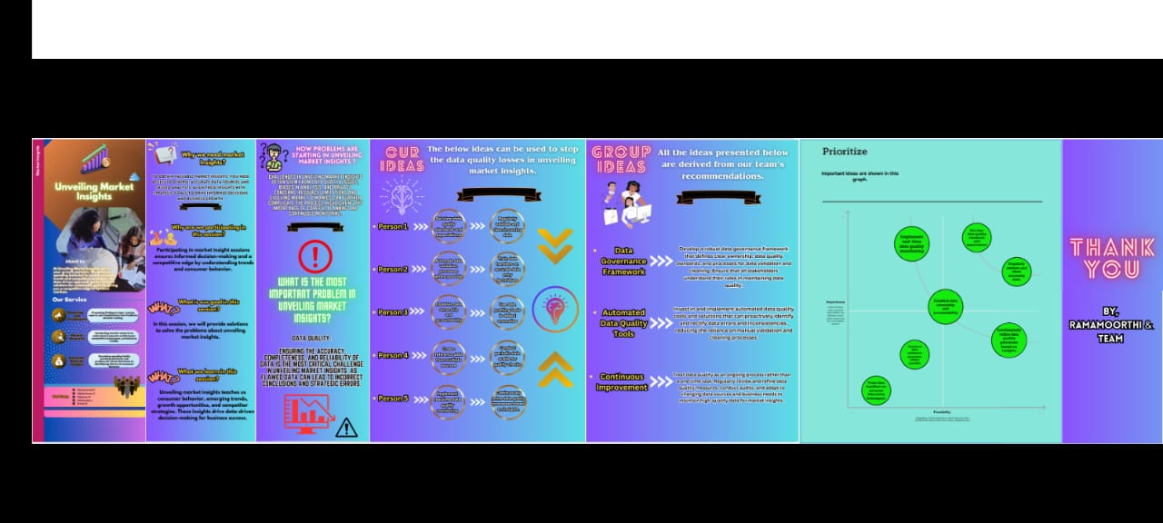

RESULT:

SCREEN SHOT
Dashboard 1:
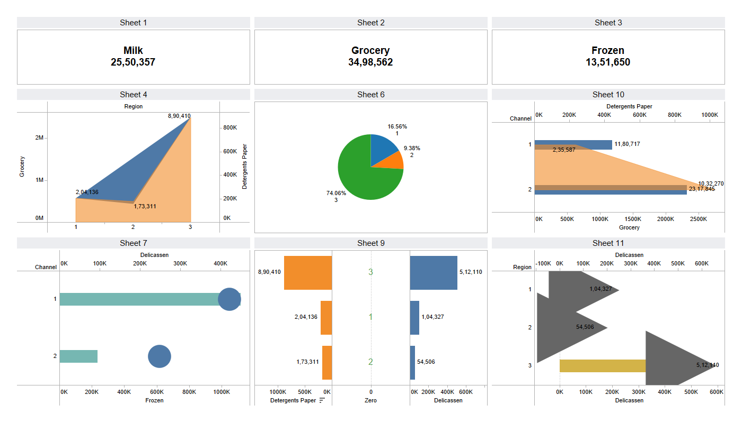

STORY

- ADVANTAGES & DISADVANTAGES:
Unveiling market insights can provide several advantages for businesses and organizations. These insights are derived from in-depth analysis of market data, consumer behavior, and industry trends. Here are some of the key advantages:
- Informed Decision-Making: Market insights provide valuable information that can help organizations make informed decisions about their products, services, and overall business strategy. This can lead to more effective and strategic decision-making.
- Competitive Advantage: Understanding market trends and consumer preferences can give a company a competitive edge. By staying ahead of the competition, a business can develop and market products or services that better meet customer needs.
- Targeted Marketing: Market insights allow businesses to tailor their marketing efforts to specific demographics, customer segments, or regions. This targeted approach can lead to higher conversion rates and more effective marketing campaigns.
- Risk Mitigation: By staying informed about market dynamics, organizations can better anticipate potential risks and challenges.
While unveiling market insights can be highly beneficial, it's essential to consider potential disadvantages and challenges associated with this process:
- Competitive Response: Sharing market insights with the public or even within your organization can prompt competitors to respond quickly. They may replicate your successful strategies, which can erode any competitive advantage you've gained.
- Cost and Resource Intensity: Unveiling market insights typically requires significant resources, including data collection, analysis, and the involvement of skilled professionals. This can be costly and time-consuming.
- Information Overload: In some cases, businesses may collect an overwhelming amount of data and insights, making it challenging to discern which insights are most relevant and actionable. This can lead to analysis paralysis.
- Misinterpretation: Misinterpreting or misusing market insights can have negative consequences. If decision-makers fail to understand the data correctly, they may make flawed decisions that harm the business.
- Rapid Market Changes: Markets can evolve quickly, and insights gathered today may become outdated in a short time. Relying too heavily on historical data or insights can lead to making decisions based on outdated information.
- Data Security and Privacy Concerns: Gathering and sharing market insights may involve sensitive customer or proprietary data. Maintaining data security and ensuring compliance with privacy regulations is crucial to avoid legal issues and reputational damage.

- APPLICATIONS:
Unveiling market insights has various practical applications across industries and can benefit businesses in numerous ways:
- Product Development and Improvement: Market insights can guide the development of new products or the enhancement of existing ones. By understanding customer needs and preferences, companies can create products that are more likely to succeed in the market.
- Market Segmentation: Insights help businesses identify and define customer segments with distinct preferences and behaviors. This allows for more targeted marketing and product customization.
- Marketing Strategy: Market insights inform marketing strategies. Companies can tailor their messaging, channels, and timing to reach the right audience effectively.
- Competitive Analysis: Understanding market dynamics enables businesses to assess their competition more accurately. Companies can identify opportunities to outperform rivals or collaborate with them when advantageous.
- Pricing Strategies: Insights into the market can help determine appropriate pricing strategies, whether it's to gain market share, maximize profit margins, or implement dynamic pricing.
- Supply Chain Optimization: By analyzing market trends, companies can better predict demand and optimize their supply chain processes, reducing costs and improving efficiency.
- Risk Management: Market insights can help identify potential risks and market fluctuations. This enables companies to implement risk management strategies to protect against adverse market conditions.
- Investment Decisions: Investors can use market insights to make informed decisions about where to allocate their resources. This includes investing in specific industries or companies.
- Expansion Opportunities: Market insights can identify potential growth markets, both domestically and internationally. Businesses can use this information to make decisions about expanding into new regions.
- Customer Service and Experience: Insights can inform improvements in customer service and experience. By understanding customer feedback and preferences, businesses can enhance their services and build customer loyalty.

- CONCLUSION:
- In conclusion, unveiling market insights is a powerful and invaluable practice for businesses and organizations across different industries. The advantages of utilizing market insights are numerous, including informed decision-making, competitive advantage, targeted marketing, risk mitigation, product development, and innovation. However, it's essential to be mindful of potential disadvantages, such as competitive responses, cost and resource intensity, information overload, and the risk of misinterpretation.
- The practical applications of market insights are wide-ranging, influencing product development, marketing strategies, competitive analysis, pricing strategies, and many other aspects of business operations. It is a vital tool for optimizing operations, enhancing customer experiences, and maintaining a competitive edge in a dynamic and ever-evolving market landscape.

- FUTURE SCOPE:
The future scope of unveiling market insights is promising and likely to evolve in several ways as technology, data analytics, and business practices continue to advance. Here are some key aspects of the future scope for market insights:
- Advanced Data Analytics: As technology continues to progress, businesses will have access to more sophisticated data analytics tools. This will enable deeper and more accurate insights, including predictive analytics, sentiment analysis, and more advanced machine learning models for data interpretation.
- Big Data and AI: The growing volume of data, including unstructured data from social media, IoT devices, and other sources, will play a significant role. Artificial intelligence and machine learning algorithms will become even more integral to processing and extracting actionable insights from big data.
- Personalization: Market insights will drive even greater personalization in marketing and product development. Companies will increasingly tailor their offerings to individual customer preferences, creating a more customized and satisfying consumer experience.
- Real-time Insigts: The demand for real-time insights will grow. Businesses will seek to make decisions and adapt strategies on the fly as market conditions change rapidly. Real-time analytics tools will enable this agility.
- Global Markets: With increased globalization, market insights will extend to international markets. Businesses will need to understand and respond to diverse consumer preferences, cultural differences, and regulatory environments across the world.

